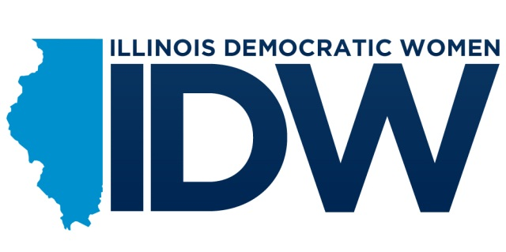
2012 Annual Convention Ad Book Form
Deadline April 15, 2012

Please make checks payable to:
Illinois Democratic Women
P.O. Box 195
Bunker Hill, IL 62014

Email information to:
Monetti@royell.org

Pay Online:
https://secure.actblue.com/page/2012idwconvention
_____ $500 Sponsor Ad
_____ $200 Full Page Ad
_____ $150 3/4 Page Ad
_____ $100 1/2 Page Ad
_____ $50 1/4 Page Ad

Name: ______________________________________________________________________
Organization: _________________________________________________________________
City: _____________________ State: __________________ Zip Code: __________________
Phone Number: _____________________ Email: ____________________________________
Remarks for the ad: ____________________________________________________________
____________________________________________________________________________
____________________________________________________________________________

Signature: _______________________________________
Convention Details:
IDW Annual Convention
Dates: April 27 & 28, 2012
Location: Crowne Plaza, Springfield, Illinois
www.illinoisdemocratwomen.org/convention

For questions or more information on the ad book, please contact Pam Monetti at 618.444.2891

Paid for by Illinois Democratic Women. A copy of our report is (or will be) on file with the State Board of Elections, Springfield, Illinois. Political contributions are not deductible for income tax purposes.

